A list of all ten sensors:

Location 1: Campus Dr and Presidential Ave

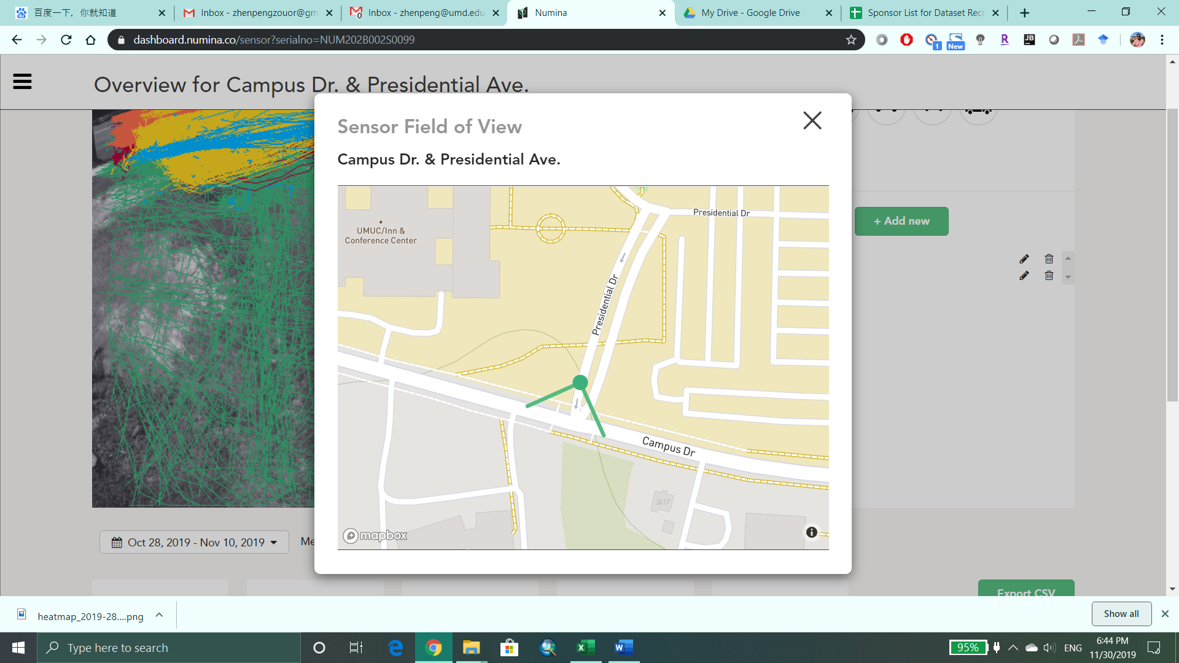

Location 2: Campus Dr at Paint Branch Dr

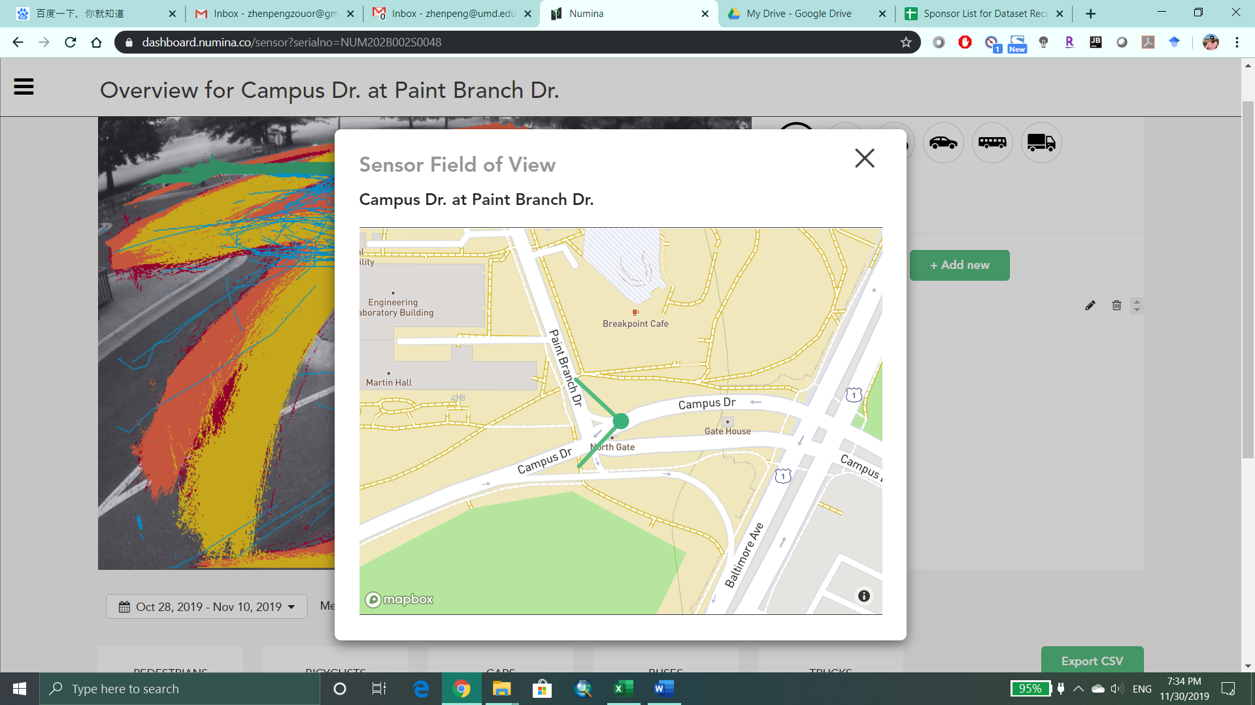

Location 3: Paint Branch Dr at Campus Dr

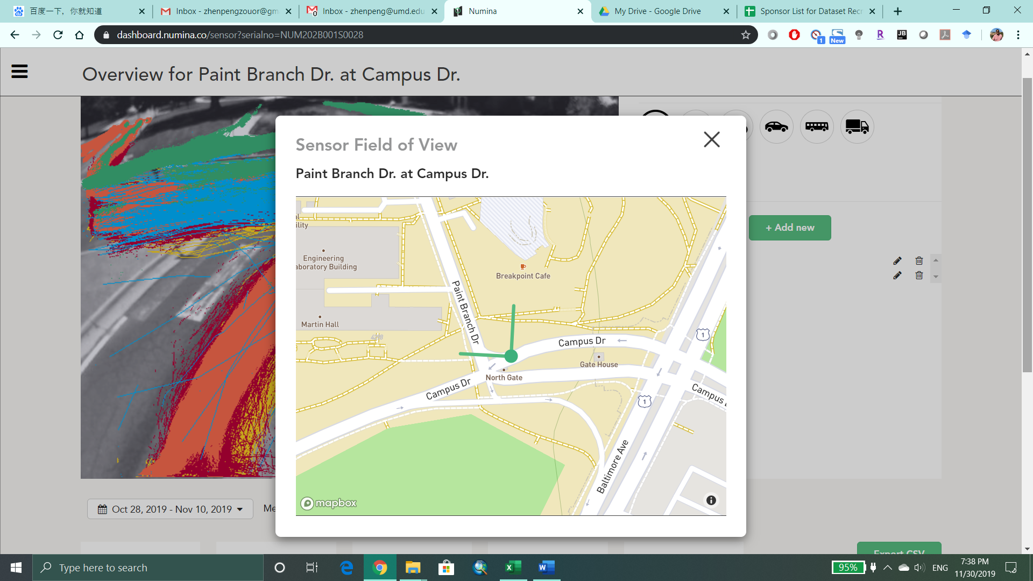

Location 4: Regents Dr & Stadium Dr – 1

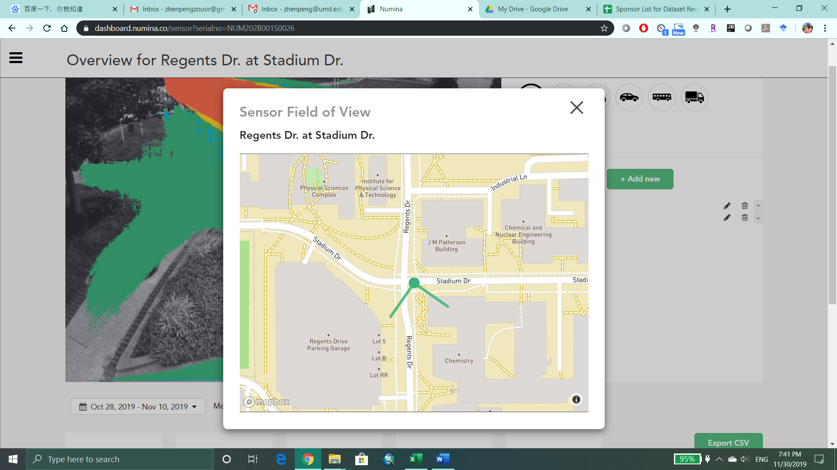

Location 5: South Gate (Northern View)

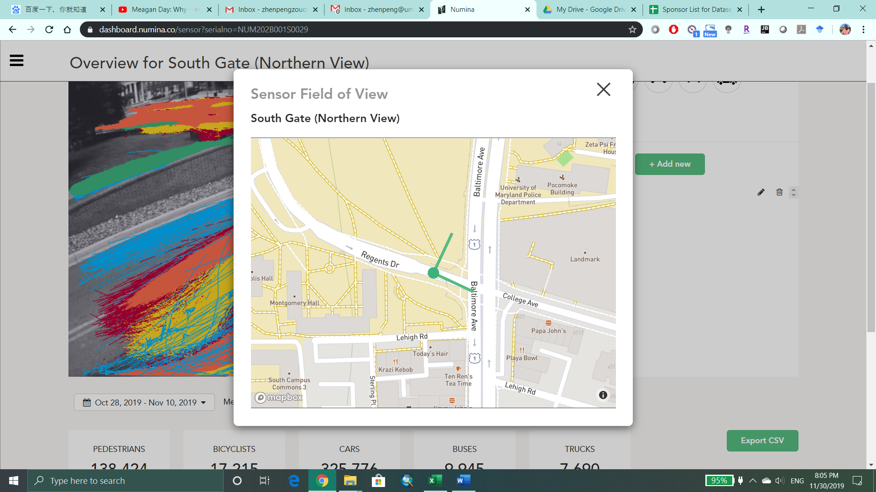

Location 6: South Gate (South View)

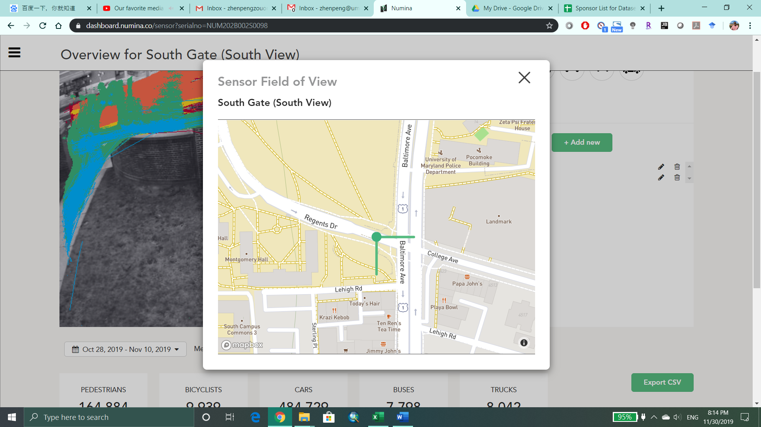

Location 7: Regents Dr & Stadium Dr – 2

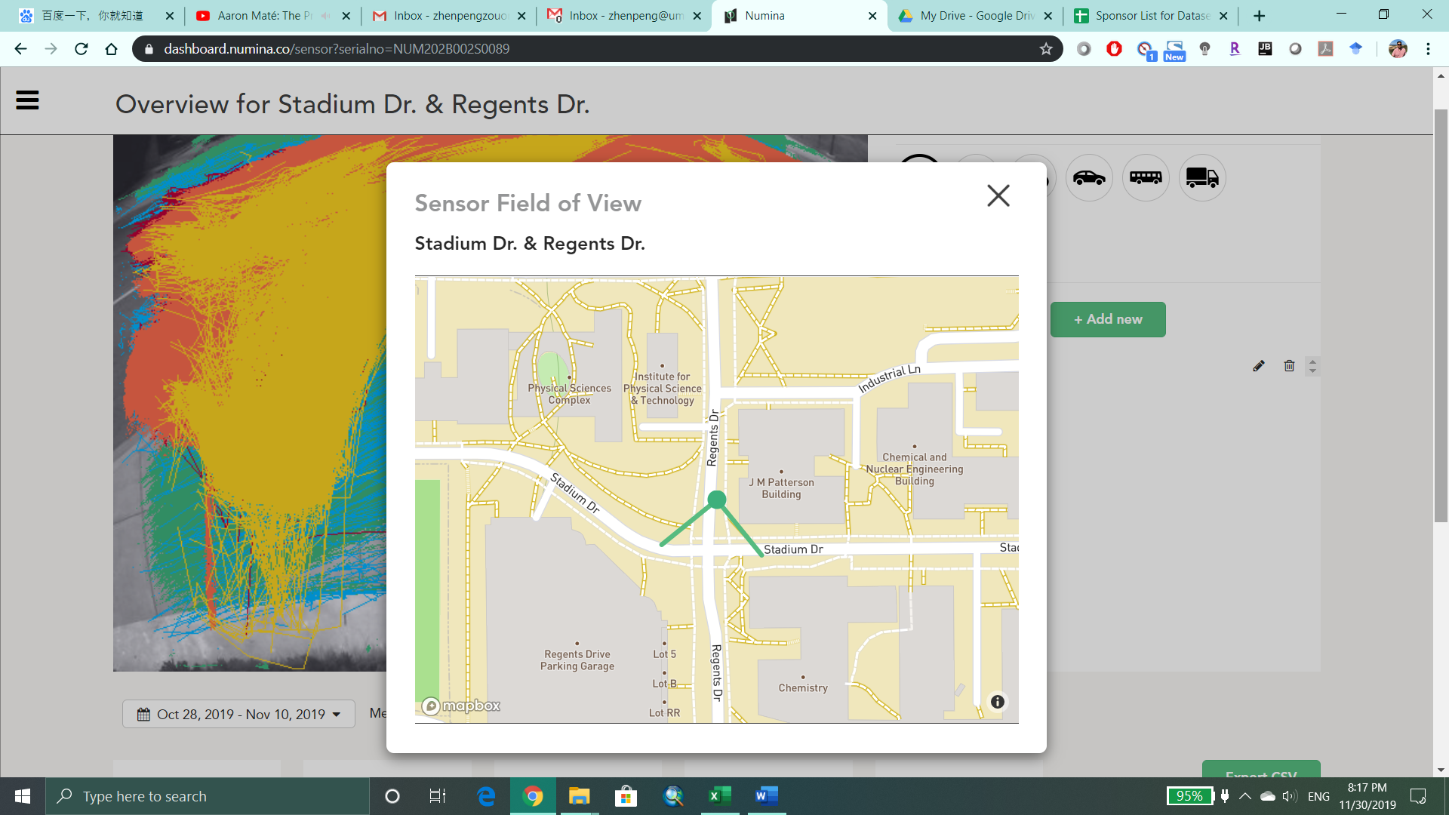

Location 8: Regents Dr & Stadium Dr – 3

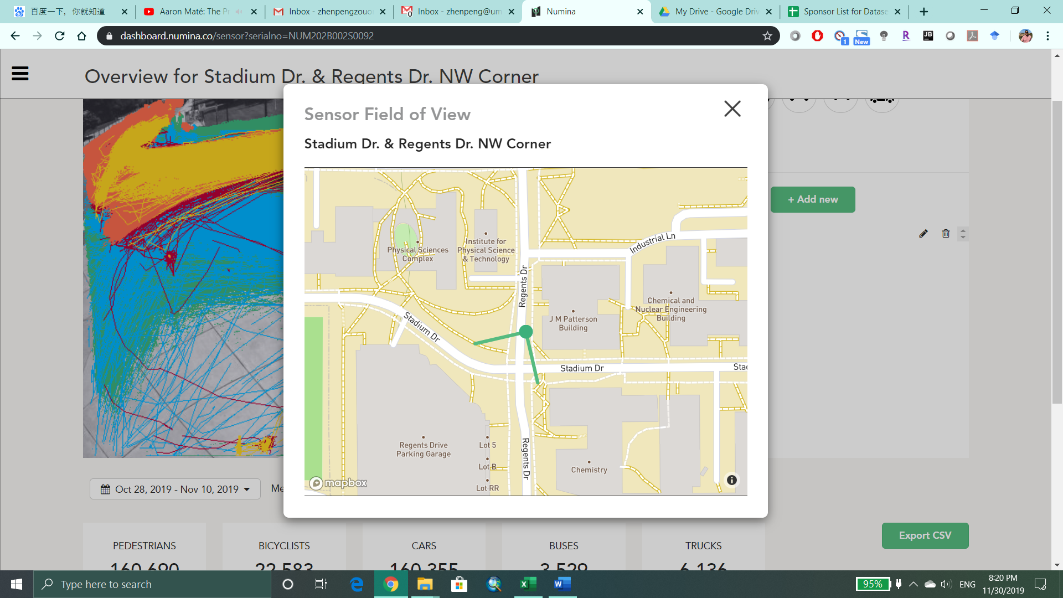

Location 9: Stadium Dr East of Regents Dr

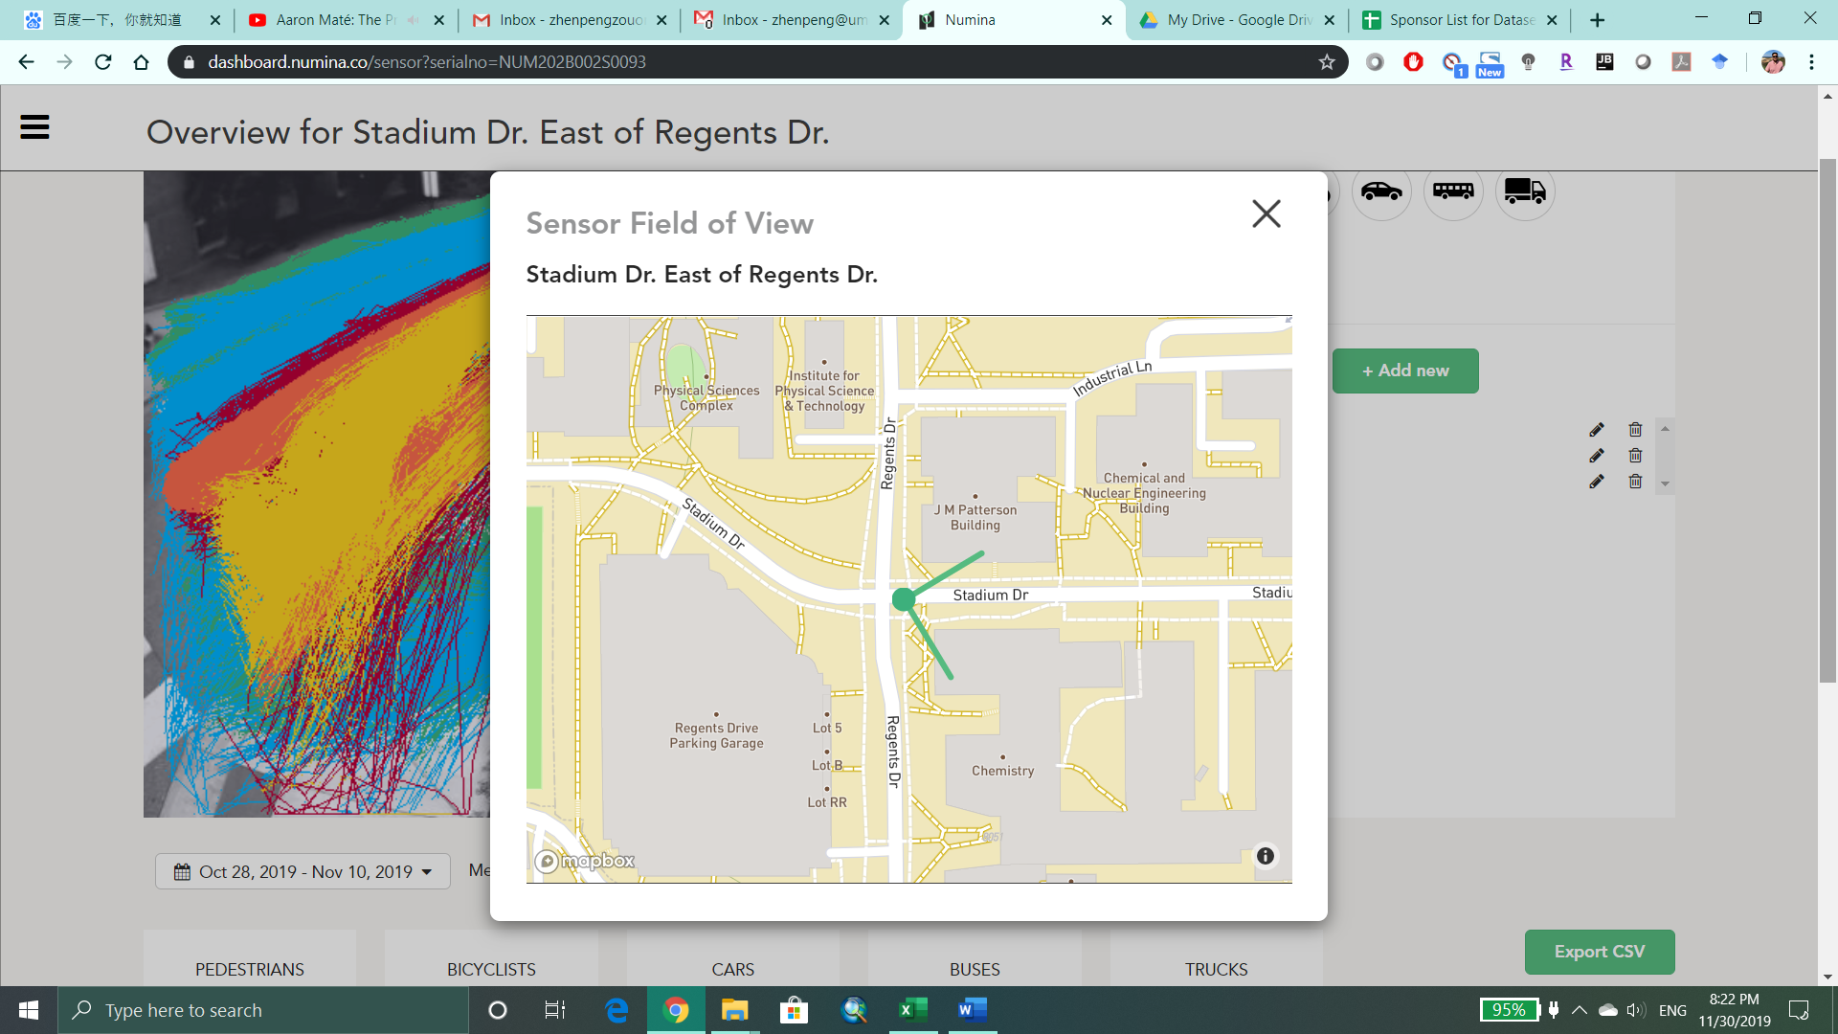

Location 10: University Blvd & Paint Branch Dr

